

**Computer Science Department**

**COMP133 ( Spring 2020)**

**Project Phase One *Due Date: Mon. 27/4/2020 by 10:00 pm ( on Ritaj )***

Notes:

The Project Phases should be submitted by the due date and time ( Late Project phases will not be accepted for any reason ) on Ritaj.

The project phases are individual student effort and copying those phases will be treated as a cheating attempt, which may lead to FAILING the course. **_______________________________________________________________**

Each student will have to build a ***bookstore management system*** for adding, deleting, or searching for books in the store. Each book will have a title (*string*), bin number (*four digit integer*), and a price (*double*). When the program starts, it will load existing book information from a text file and when the program exits, it will save all changes made while running the program to that same file.

After the book information is loaded from the file ***( In this phase all you need to do is just print a message that the book information is loaded, but you don’t really open any files or load anything)*** , the program will display the following main menu to the user:

***Please Select an Operation (1-4):***

***1- Add a Book***

***2- Remove a Book***

***3- Search for a Book***

***4- Exit System***

This menu will keep showing after each time a user selects an operation and that operation is performed. When the user selects operation 4 (exit system), the program will load all changes (updates) to the file ***( In this phase all you need to do is just print a message that the book information is updated, but you don’t really open any files or update anything)*** and will then exit.

Your program should at least contain the following functions:

void displayMainMenu(); // displays the main menu shown above

void addBook(); // adds information for a new book

void removeBook(); // removes information of old book

void searchForBook(); // searches for a book in the store

void uploadDataFile(); // uploads book data from file

void updateDataFile(); // saves book data updates to file

***For this phase those functions are just void functions that will mostly contain printf statements just to print what they are supposed to do. In later phases, the function prototypes will change and the functions will do more.***

**Items that should be turned in by each student:**

1. ***A copy of your program code.***
2. ***An image file of a complete run similar to the output shown on page 3.***

***( To do this you can PrintScreen when you run your program and then paste into the paint program and then save it as an image file )***

1. Turn in your project phase by ***replying to the course coordinator’s message*** on Ritaj and attaching both your code file + run image file.
2. **Your name and id number should be included in the code file as a comment.**

Make sure your program works **very similar** to the following sample run:

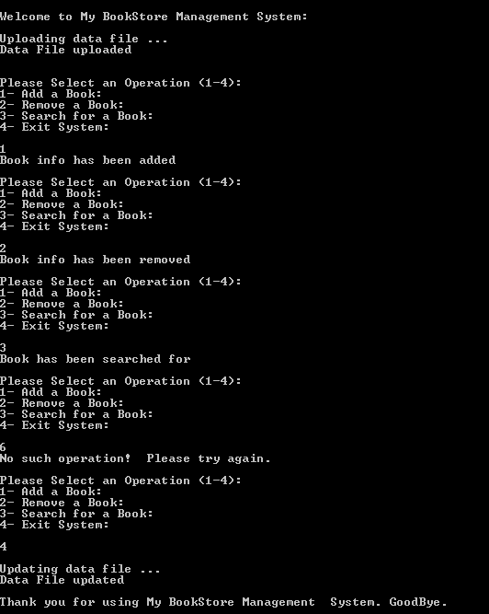

***Late project phases will not be accepted for any reason***.